# TASKS TO MAKE GIT REPOSITORY

# **OPEN GITHUB AFTER SING IN THEN CLICK CREATE REPOSITORY**

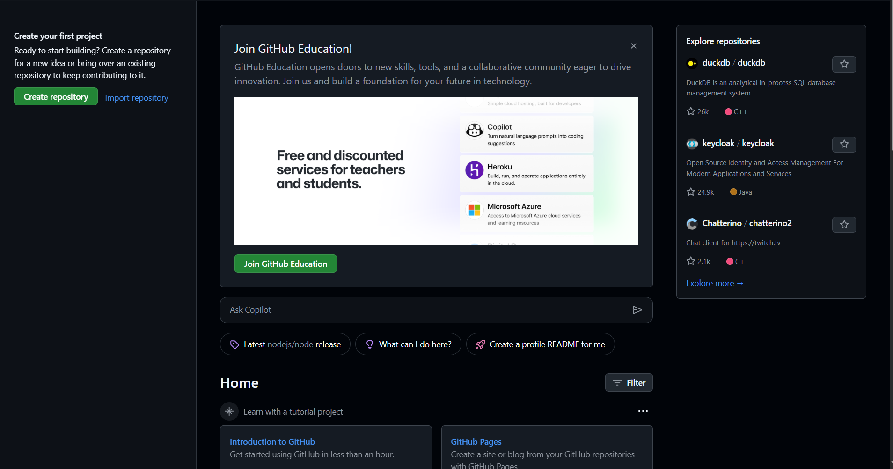

**ENTER ENROLLMENT NO. AS REPOSITORY NAME**

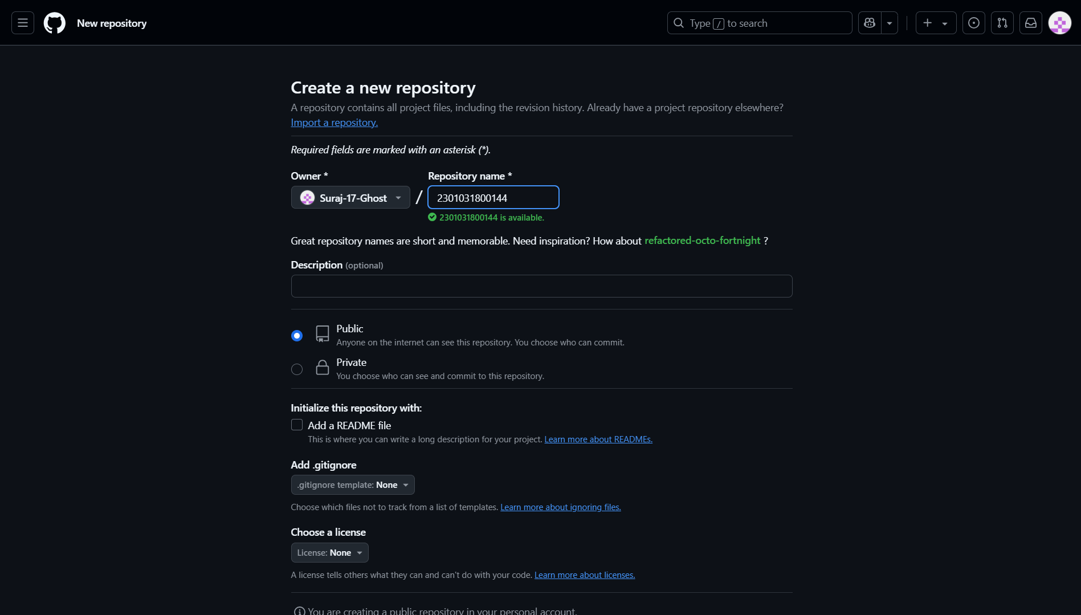

**Click on the Creating New File To Create New File**

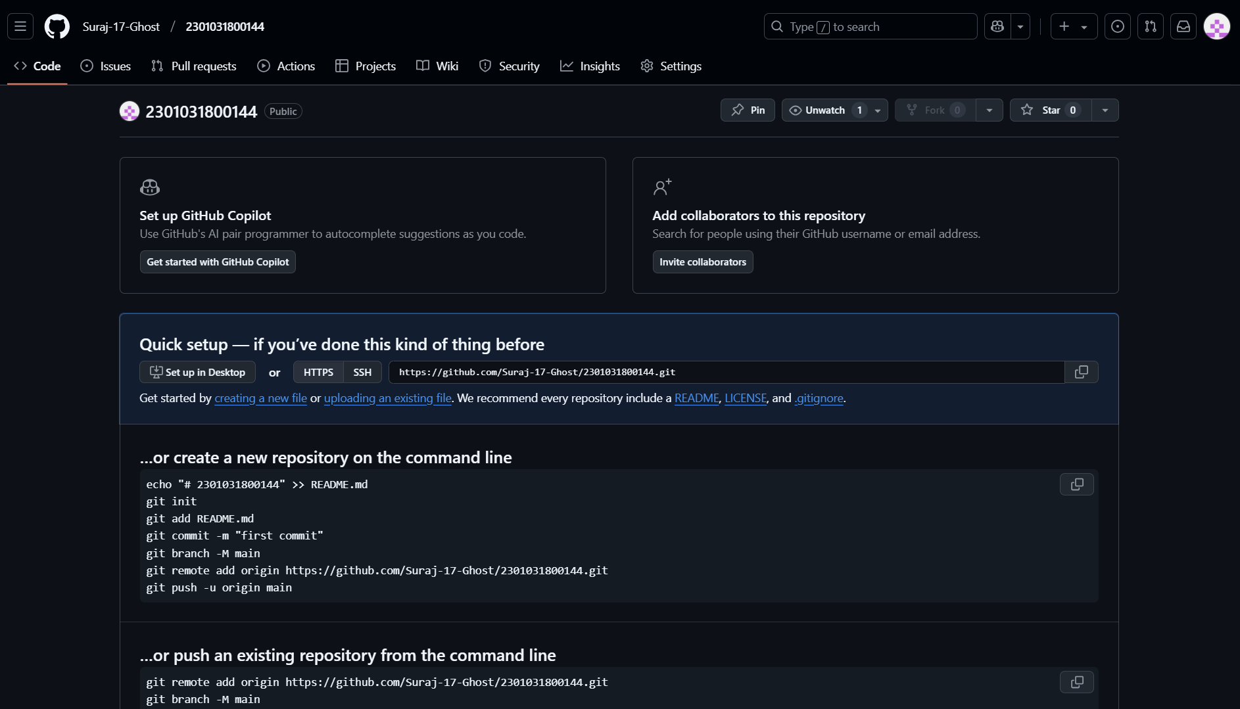

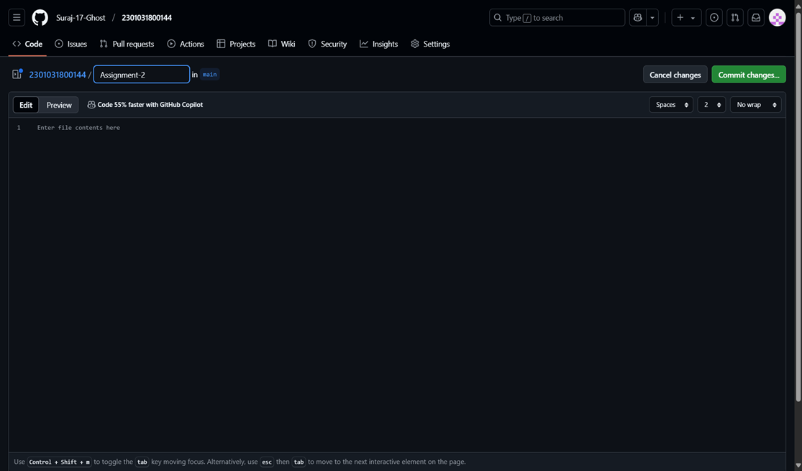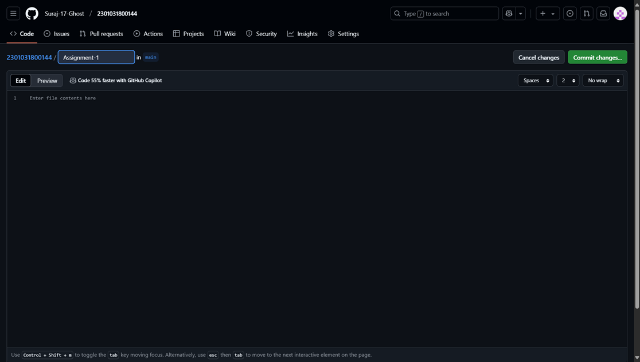**AFTER CREATING REPOSITORY CREATE 2 FILES AS ASSIGNMEN-1 AND ASSIGNMENT-2 RESPECTIVELY**

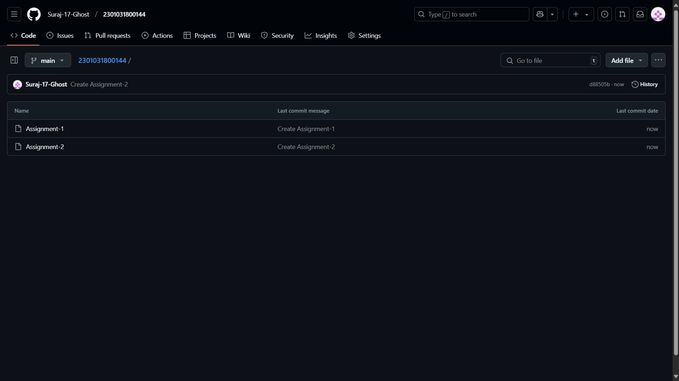**Your Both Assignment-1 and Assignment-2 Will be created in your Git Hub**